Welcome to Morocco!!

We are excited that you are considering joining us on our upcoming trip to Morocco! Below is a tentative itinerary for an 11-night/12-day trip to Morocco. Departure is planned for sometime between June 19 and July 1, 2023. The exact date of departure is yet TBD, and depends mainly on Eid Al-Adha. There is a possibility to extend the trip either with a small group or on your own. The order of the itinerary (beginning and ending cities) depends mainly on ticket costs, but below are the main sites included.
As an integral part of the program, we will be interacting with local Moroccans from different walks of life. We will enjoy home hospitality, local music, a Sufi session, visits to women’s co-ops, interfaith activities, and more. We will attempt to keep the group relatively small, while still being cost effective.
To learn more, please visit www.illiinitiatives.com. For additional information contact Dr. Adina Friedman at illiinitiatives@gmail.com and/or 703-725-2926.

Tentative Itinerary:
Day 1: Casablanca
Day 2: Rabat, Chefchaouen
Day 3: Meknes, Fes
Day 4: Fes
Day 5: Fes- Erfoud, Merzouga
Day 6: Ouarzazzate and/or Tinghir
Day 7: Dades Valley, Ait Ben Haddou, Marrakech
Day 8: Marrakech environs/ High Atlas Foundation
Day 9: Marrakech
Day 10: Essauira
Day 11: Essauira-Safi-ElJadida -Casablanca
Day 12: Departure

Cost Includes:
- Luxury bus for duration of trip
- Hotels/Riads; one night in luxury tents in the Sahara
- All breakfasts, some lunches/dinners
- Camel rides in the Sahara sand dunes
- Home Hospitality
- Meetings with local resource people and community members
- Musical performances (Gnawa, Amazigh); Sufi Session
- Local English-speaking guide/s
- Tour manager with subject-matter expertise for duration of the trip
- Activities with High Atlas Foundation (visits to villages, tree nurseries, and women co-ops)
- Entrance fee to monuments mentioned in the itinerary
- Daily mineral water bottle
- Some tips

Not Included:
- Air fare
- Most lunches, some dinners
- Tips for Moroccan guide/s & driver (suggested at $5/day per person)
- Health insurance
- Any other service not mentioned above
Morocco: 11 Nights

DAY 1: Casablanca

Arrival at & pickup from Casablanca’s Mohamed V Airport; travel to Casablanca (45min-1hour), Morocco’s largest city and economic capital.

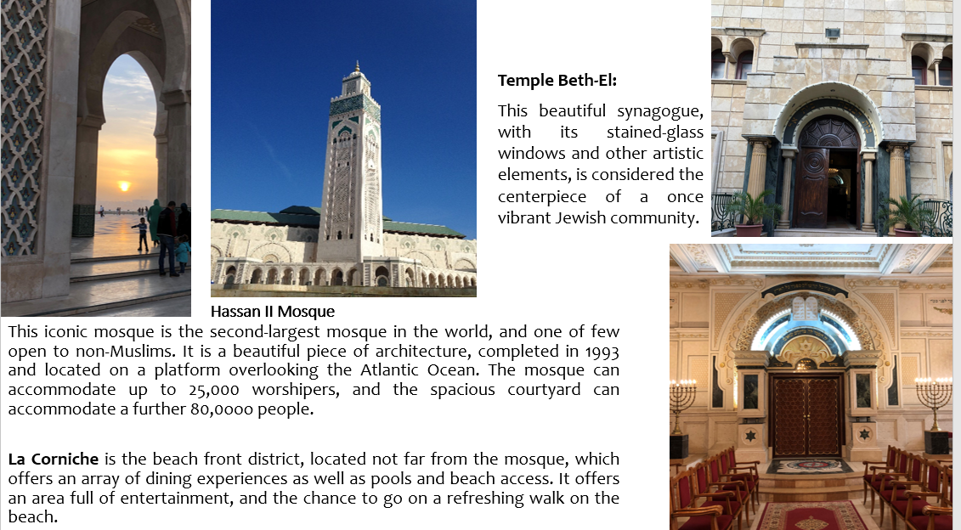
After our city tour, we will enjoy a welcome dinner with local resource people, and an introduction to trip and to Morocco.
Accommodations: Casablanca or Rabat (depending on time of arrival to Morocco)

DAY 2: Rabat; Chefchaouen

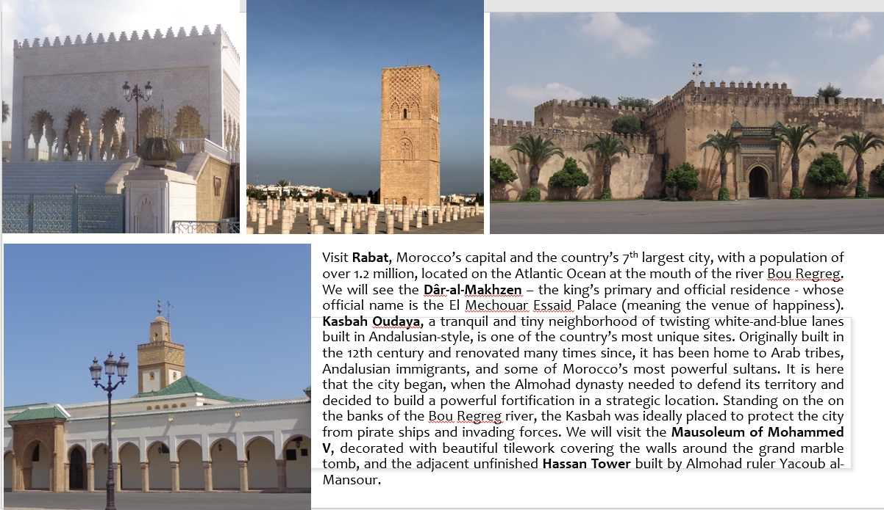
From Rabat we will drive north to Chefchaouen.

Chefchaouen
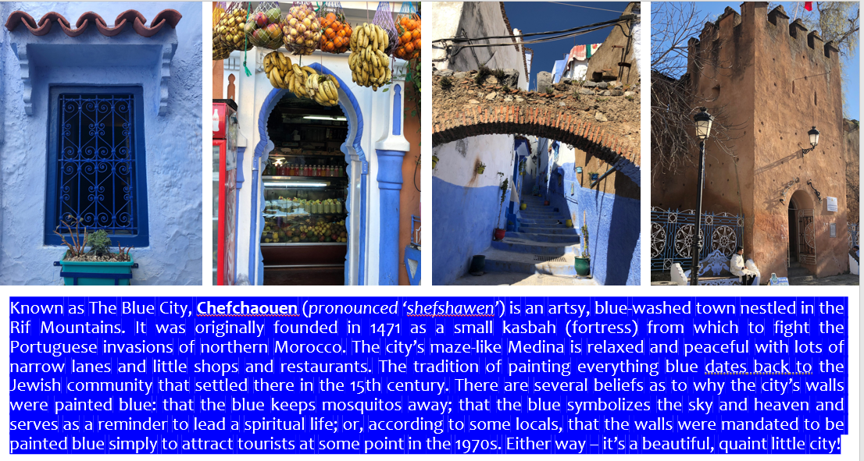
Accommodations: Chefchaouen.

DAY 3: Meknes; Fes
After a relaxing breakfast in Chefchaouen, we will head to Meknes, and from there to Fes.
Meknes
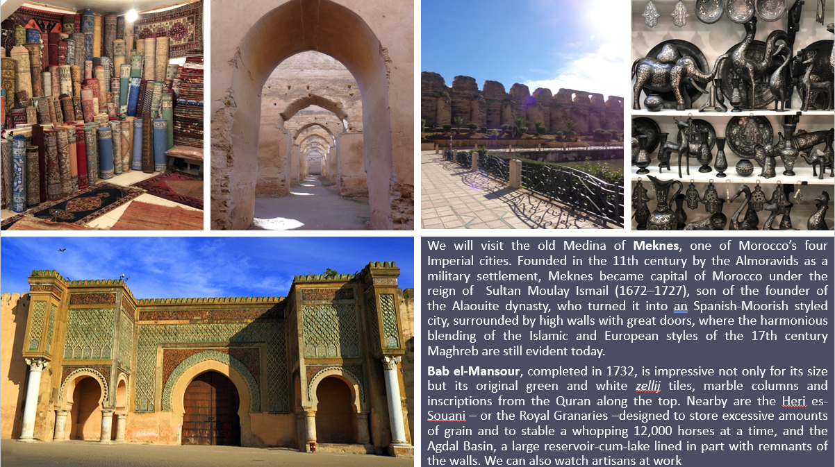
From Meknes we will continue to Fes, where we will be joined for dinner by local students and members of Mimouna Association, which works to educate Moroccan Muslims about Jews and Judaism, and to advance Jewish-Muslim relations.
Accommodations: Riad in Fes.
DAY 4: Fes
We will spend today in Fes, the oldest of the Imperial cities and the religious capital of the kingdom, and the second largest city in Morocco after Casablanca. It was founded under Idrisid rule during the 8th-9th centuries CE. Successive waves of mainly Arab immigrants from Ifriqiya (Tunisia) and al-Andalus (Spain/Portugal) in the early 9th century gave the nascent city its Arab character. Under Almoravid rule, the city gained a reputation for religious scholarship and mercantile activity, and during the Marinid era (13th-15th centuries), it regained its status as political capital.
Fes has the largest medina in North Africa, and over 9,000 tiny streets and alleys still filled with ancient mosques, towering green-glazed minarets and often-crumbling foundouks (hostels for travelers and their donkeys). Arched doorways lead to pristine private worlds, tranquil courtyards filled with carved cedar, brilliantly colored intricate mosaic tiles, and plaster delicately engraved with quotes from the Koran. It is perhaps the world’s largest (and most challenging) maze. It is also the world’s largest surviving medieval city. Fes has always been the cultural, religious, and intellectual heart of Morocco. The world’s oldest university is in Fes, older than any in Europe. The libraries of Fes house treasure troves of rare manuscripts. It was Fes that welcomed Jewish and Muslim scientists, doctors and poets expelled from Spain after the fall of Granada in 1492.
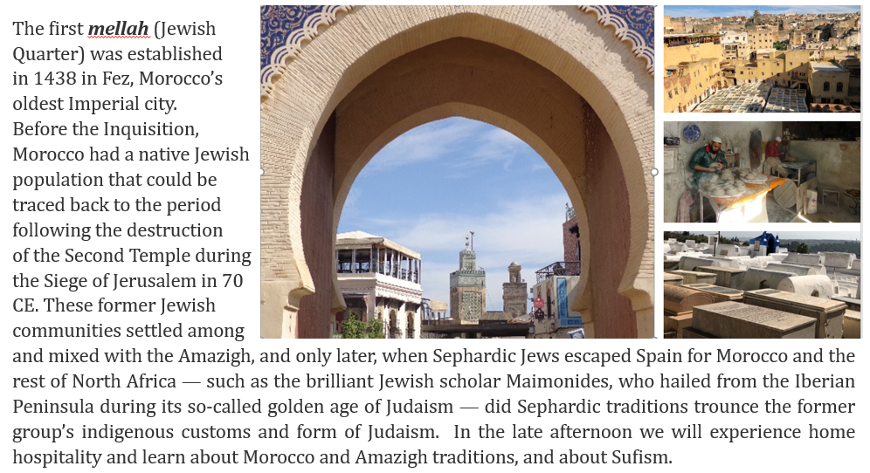
In the late afternoon we will enjoy home hospitality with a conversation on Moroccan and Amazigh culture, and a session on Sufism.
Accommodation: Riad in Fes

DAY 5: Ifrane; Azrou; Erfoud
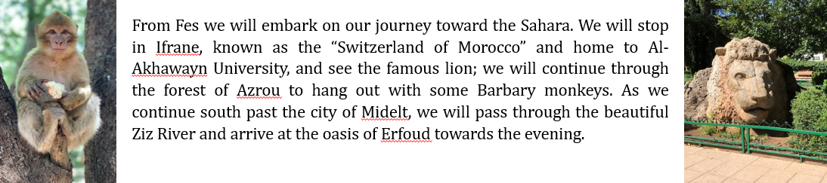
We will enjoy a quiet dinner and group reflections in the desert.

Accommodations: Desert, Erfoud (Tent hotel)

DAY 6: Merzouga; Todgha; Ouarzazzate

We will get up before sunrise, and travel by 4x4 cars to Merzouga, where we will ride camels to see the beautiful sunrise over the sand dunes. We will the return to our hotel for breakfast, and then visit the village of Khamliyah to hear some Gnawa music. We will then depart toward Tinghir, and visit the magnificent Todgha canyons. After a walk and sightseeing we will depart to Ouarzazzate through the road of 1000 Kasbahs. We will arrive in the desert town of Ouarzazzate – also known as Morocco’s movie capital - toward evening.
Accommodation: Ourzazzate
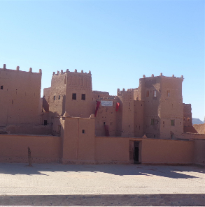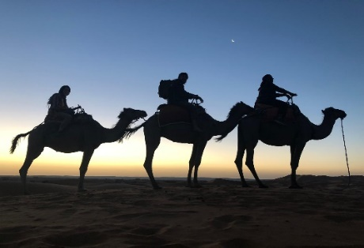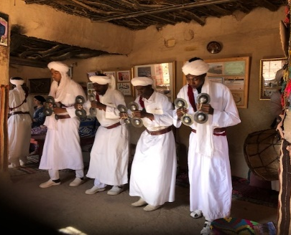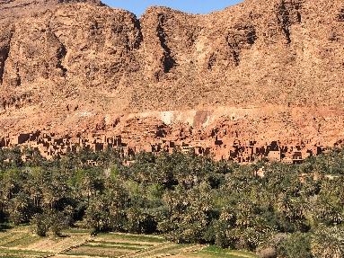

DAY 7: Ait Benhaddou; Marrakech

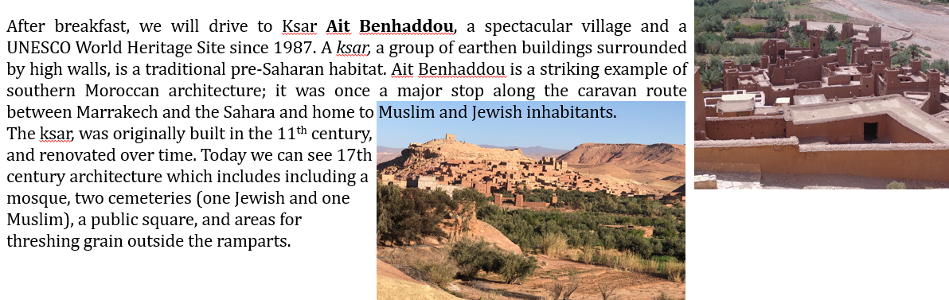

From Ait Benhaddou we will continue to Marrakech. After checking in to our hotel we will visit the ever-bustling Jemaa el-Fnaa, the busiest square in Africa, where we can see merchants, magicians, snake charmers, and other entertainers. There are dozens of restaurants where tourists and locals can enjoy dinner. Accommodation: Marrakech

Day 8: Marrakech and High Atlas

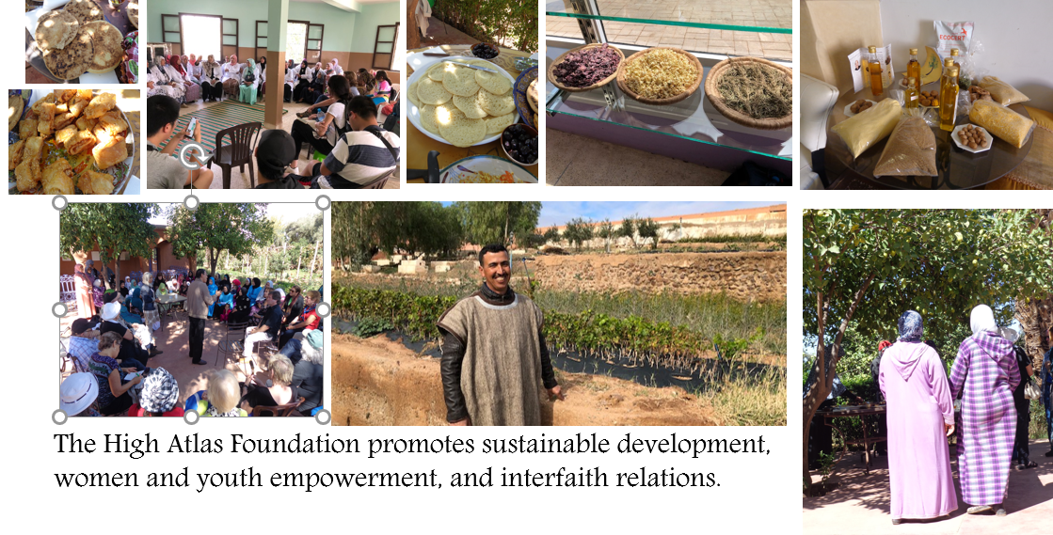
We will spend the day with HAF, visiting some of the villages and women co-ops with which they work and
engaging with them.
Accommodation: Marrakech

DAY 9: Marrakech

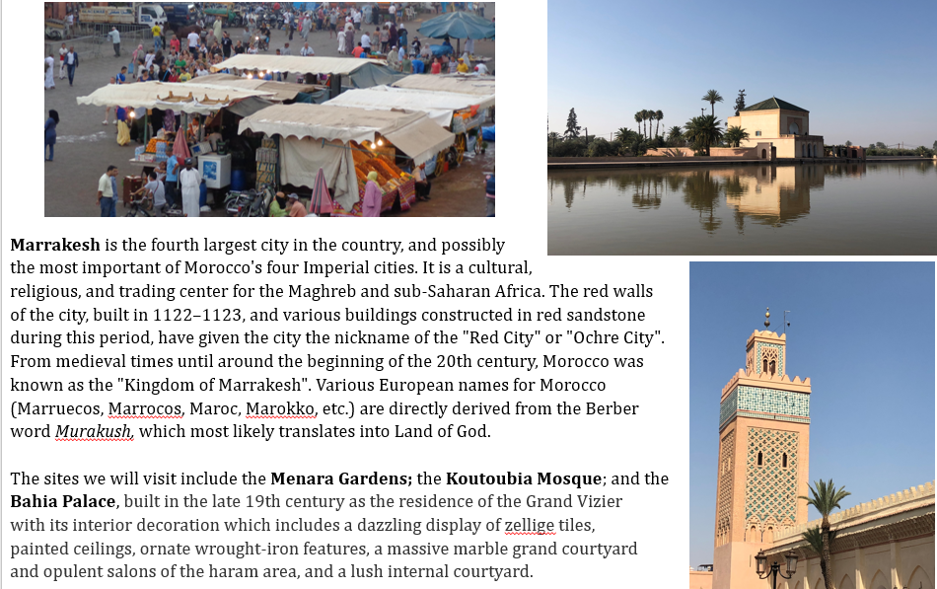
We will also visit Marrakech’s Mellah and Slat Lazamah synagogue, built by Jews expelled from Spain in 1942.
In between our site-seeing, we will pause to take a cooking class, in which we will learn some of the secrets
of the Moroccan cuisine.
Accommodation: Marrakech

Day 10: Essaouira

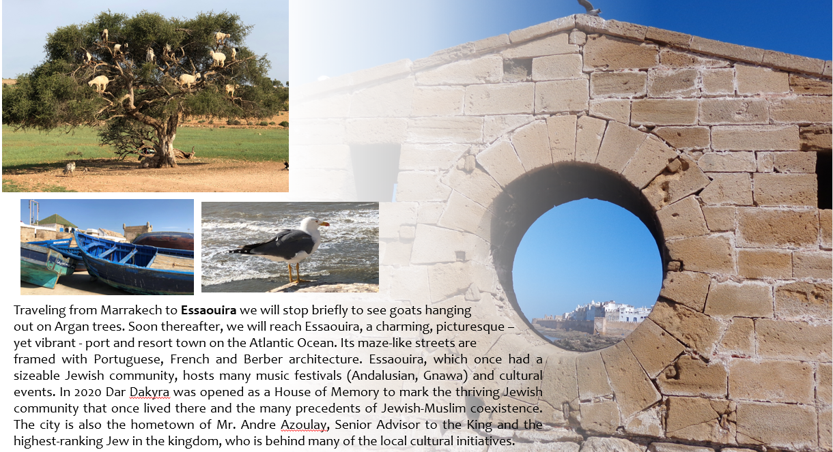
We will enjoy a lovely farewell dinner before returning to Marrakech.
Accommodation: Essauira

DAY 11: Essaouira-Safi-El Jadida -Casablanca

After breakfast we will depart Essauira and head up the Atlantic coast to Casablanca, stopping on the way in the cities of Safi and El Jadida. Safi, or Asfi, was occupied by the Portuguese Empire from 1488 to 1541, was the center of Morocco's weaving industry, and became a fortaleza of the Portuguese Crown in 1508. It is the main fishing port for the country's sardine industry, and also exports phosphates, textiles and ceramics.El Jadida's old city sea walls are one of the Seven Wonders of Portuguese Origin in the world. The Portuguese Fortified City of Mazagan was registered as a UNESCO World Heritage Site in 2004, on the basis of its status as an "outstanding example of the interchange of influences between European and Moroccan cultures" and as an "early example of the realization of the Renaissance ideals integrated with Portuguese construction technology".

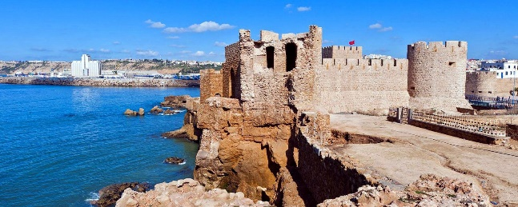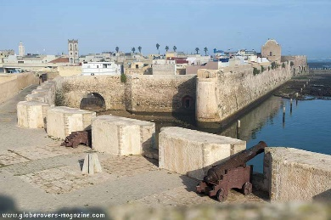
Safi El Jadida

Day 12: Departure

On this day we will depart from Casablanca. Depending on departure times, you may have some free time in Casablanca to finish up last minute shopping or sightseeing.

Trip Director:

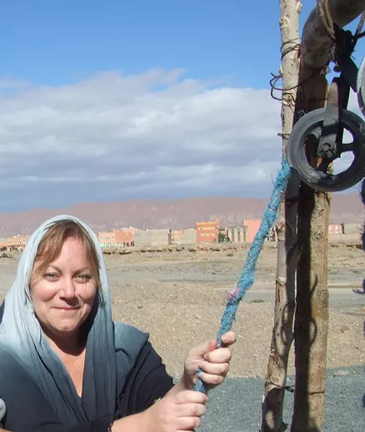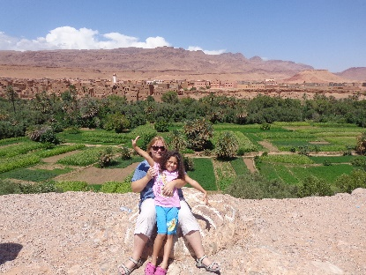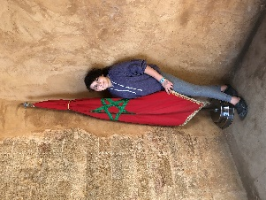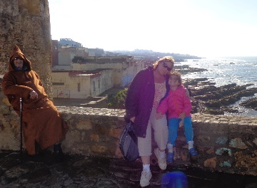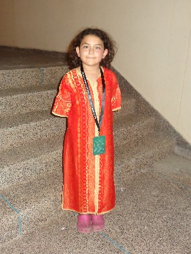

The trip is designed and led by Dr. Adina Friedman, usually accompanied by her daughter, Illi. Adina is a scholar-practitioner who has worked in the fields of peacebuilding and conflict resolution, broadly defined, for more than three decades. She has taught graduate and undergraduate courses on peacebuilding, gender, sustainable development, and the MENA, and designed and led immersion travel to Morocco, Israel/Palestine, Jordan, Egypt, Tunisia, and Serbia/Kosovo/Bosnia. Since 2005 she has been traveling to Morocco, where she works closely with local academics and students, activists, farmers, service providers, community leaders, and other resource people. Above and below are some of the trip’s highlights.

For more information, please visit www.illiinitiative.com and www.adinabfriedman.com

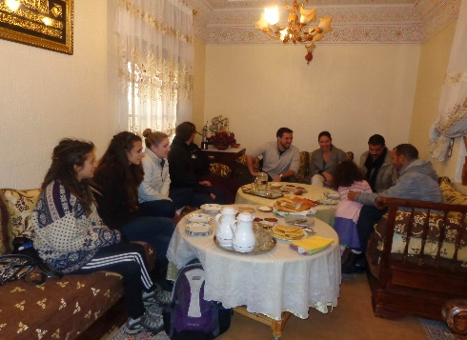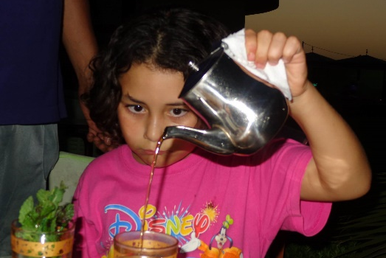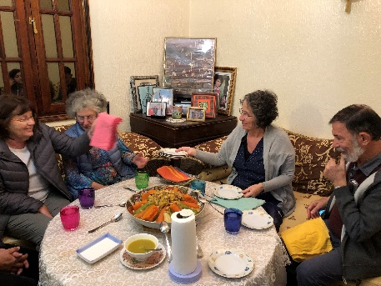
Home hospitality
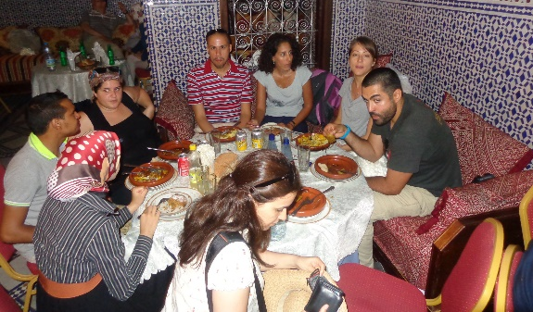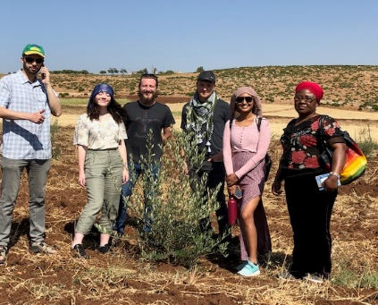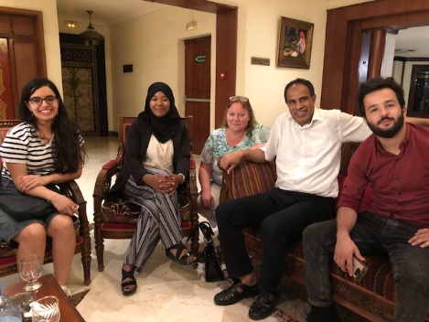
Encounters & dialogue Organic farming Meeting professor & students

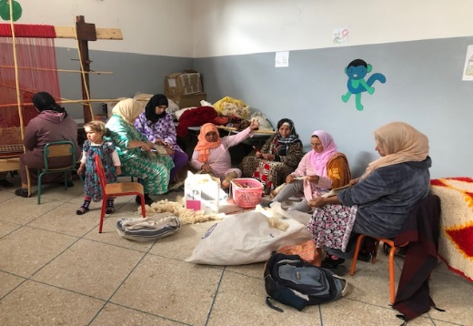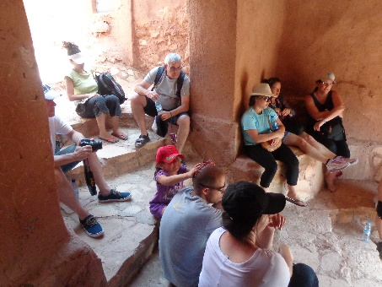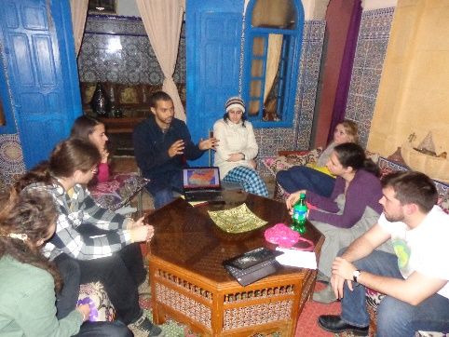
Visiting women’s co-ops Hiking Learning about history & current events

